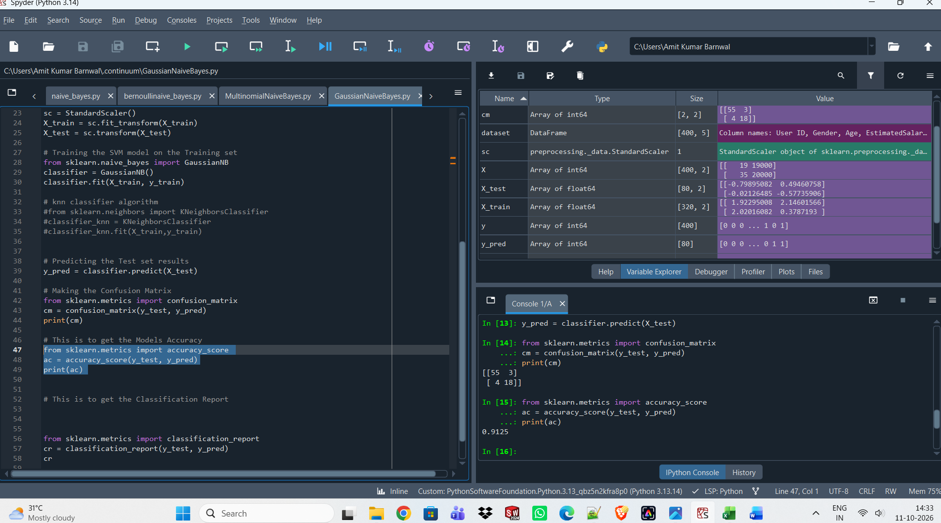
Gaussian Naïve Bayes with Scaling Features
Accuracy Model = 91.25, Bias= 88.43, Variance = 91.25
Gaussian Naïve Bayes without Scaling Features
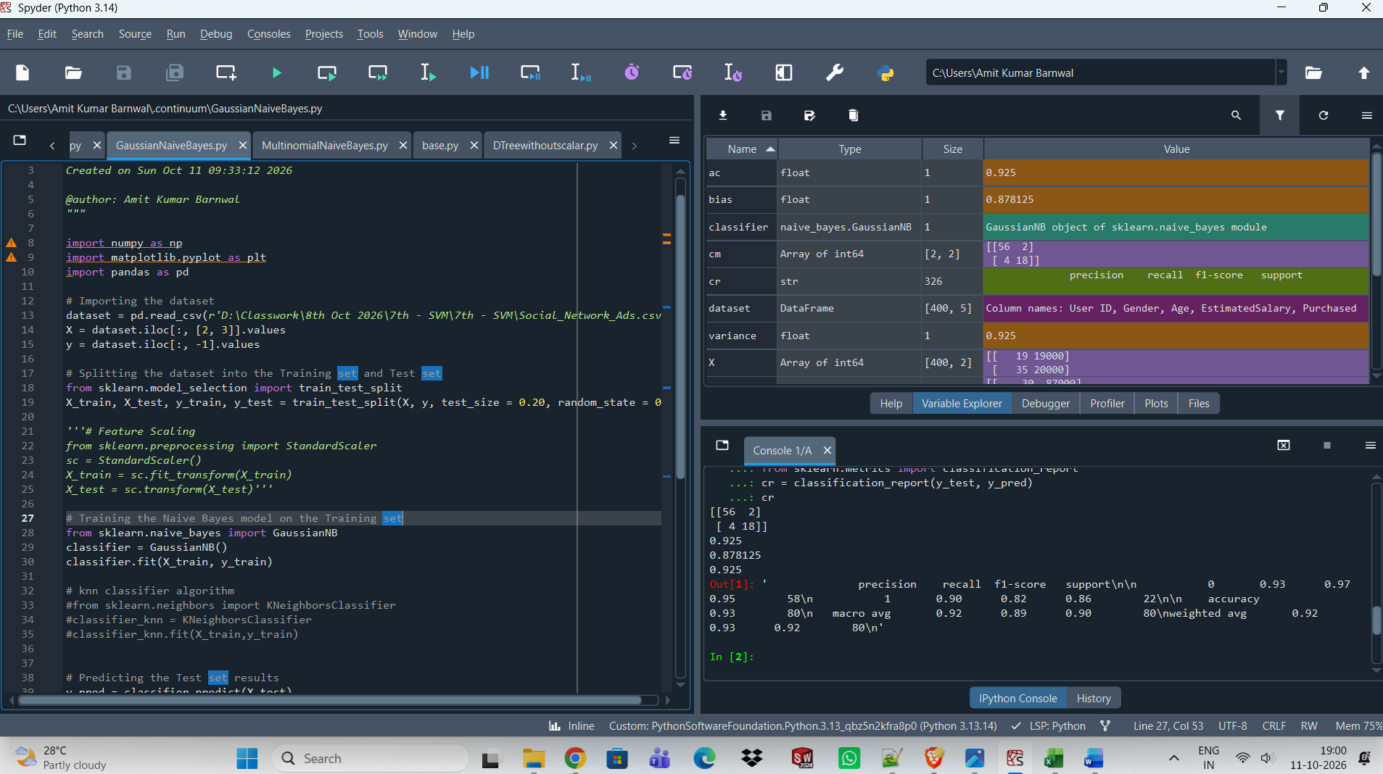
Accuracy Model = 92.5, Bias = 87.81, Variance = 92.5
Gaussian Naïve Bayes with Scaling Features | Accuracy Model = 91.25, Bias= 88.43, Variance = 91.25
Gaussian Naïve Bayes without Scaling Features | Accuracy Model = 92.5, Bias = 87.81, Variance = 92.5

Gaussian Naïve Bayes without Scaling Features > more accurate than Gaussian Naïve Bayes with Scaling Features
Q. which Naïve Bayes does not require scaling?
A. Gaussian Naïve Bayes
Bernoulli Naïve Bayes with Scaling Features

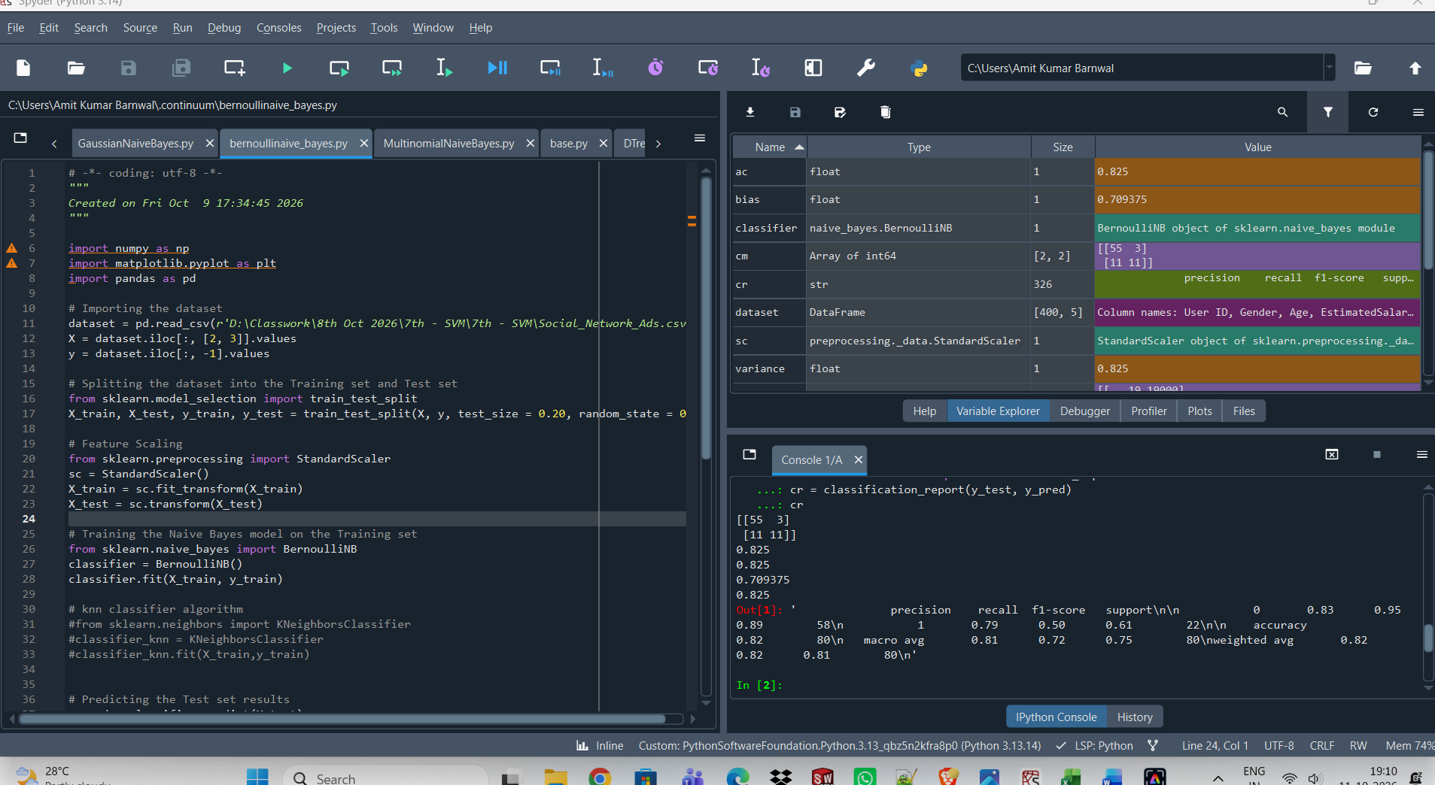

Accuracy = 82.5, Bias = 70.93, Variance = 82.5
Bernoulli Naïve Bayes without Scaling Features
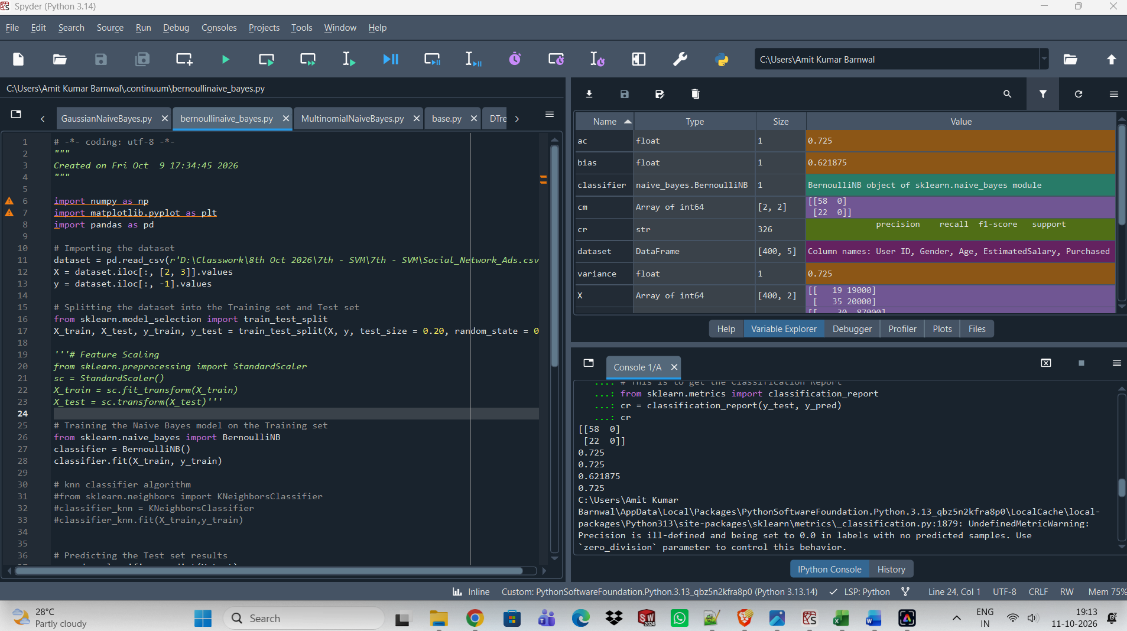
Accuracy = 72.5, Bias = 62.18, Variance = 72.5
Bernoulli Naïve Bayes with Scaling Features more accurate than Bernoulli Naïve Bayes without Scaling Features
Bernoulli Naïve Bayes with Scaling Features | Accuracy = 82.5, Bias = 70.93, Variance = 82.5
Bernoulli Naïve Bayes without Scaling Features | Accuracy = 72.5, Bias = 62.18, Variance = 72.5
Multinomial Naïve Bayes without Normaliser Scaling Features
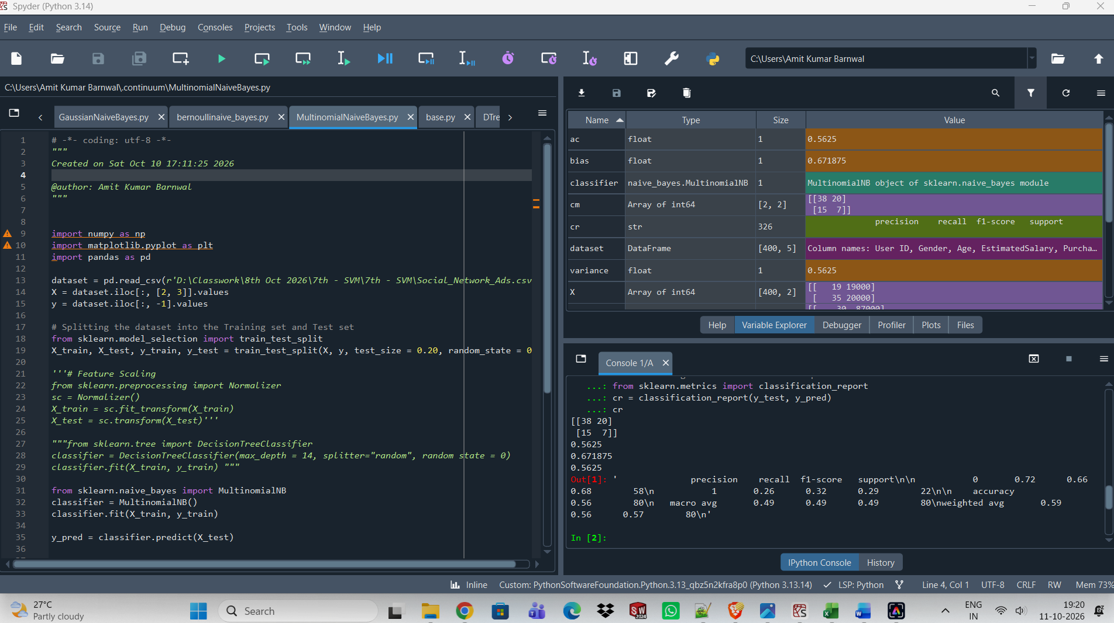
Accuracy =56.25, Bias = 67.18, Variance = 56.25
Multinomial Naïve Bayes with Normaliser Scaling Features
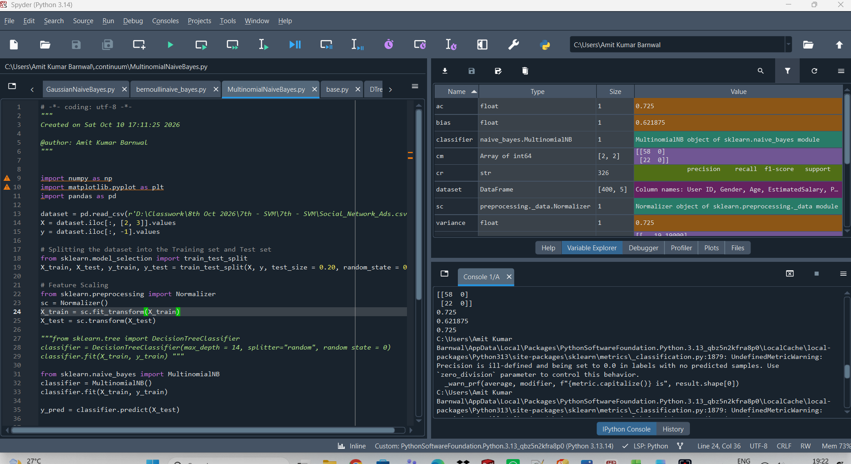
Accuracy =72.5, Bias = 62.18, Variance = 72.5
Multinomial Naïve Bayes with Normaliser Scaling Features is more accurate than Multinomial Naïve Bayes without Normaliser Scaling Features

Multinomial Naïve Bayes with Normaliser Scaling Features | Accuracy =56.25, Bias = 67.18, Variance = 56.25
Multinomial Naïve Bayes without Normaliser Scaling Features | Accuracy =72.5, Bias = 62.18, Variance = 72.5

Multinomial Naïve Bayes with Normaliser Scaling Features
import numpy as np
import matplotlib.pyplot as plt
import pandas as pd

dataset = pd.read_csv(r'D:\Classwork\8th Oct 2026\7th - SVM\7th - SVM\Social_Network_Ads.csv')
X = dataset.iloc[:, [2, 3]].values
y = dataset.iloc[:, -1].values

# Splitting the dataset into the Training set and Test set
from sklearn.model_selection import train_test_split
X_train, X_test, y_train, y_test = train_test_split(X, y, test_size = 0.20, random_state = 0)

# Feature Scaling
from sklearn.preprocessing import StandardScaler
sc = StandardScaler()
X_train = sc.fit_transform(X_train)
X_test = sc.transform(X_test)

from sklearn.naive_bayes import MultinomialNB
classifier = MultinomialNB()
classifier.fit(X_train, y_train)

y_pred = classifier.predict(X_test)

from sklearn.metrics import confusion_matrix
cm = confusion_matrix(y_test, y_pred)
print(cm)

# This is to get the Models Accuracy
from sklearn.metrics import accuracy_score
ac = accuracy_score(y_test, y_pred)
print(ac)

bias = classifier.score(X_train,y_train)
print(bias)

variance = classifier.score(X_test,y_test)
print(variance)

# This is to get the Classification Report
from sklearn.metrics import classification_report
cr = classification_report(y_test, y_pred)
cr
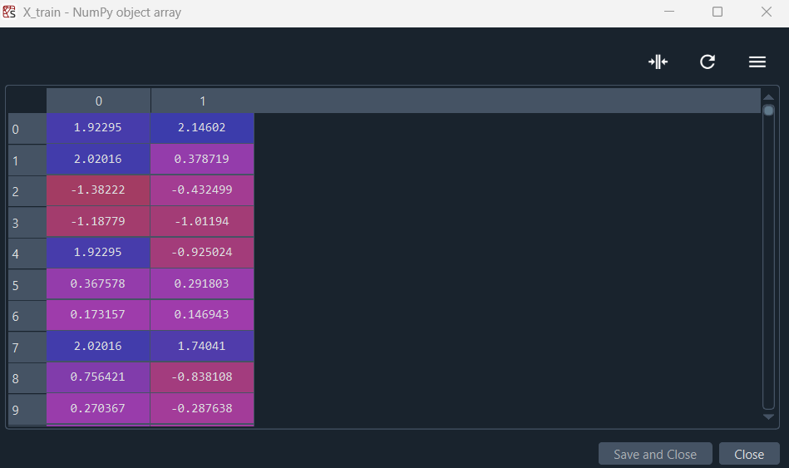

--> 921 check_non_negative(X, "MultinomialNB (input X)")
922 self.feature_count_ += safe_sparse_dot(Y.T, X)
923 self.class_count_ += Y.sum(axis=0)

File ~\AppData\Local\Packages\PythonSoftwareFoundation.Python.3.13_qbz5n2kfra8p0\LocalCache\local-packages\Python313\site-packages\sklearn\utils\validation.py:1791, in check_non_negative(X, whom)
1788 X_min = xp.min(X)
1790 if X_min < 0:
-> 1791 raise ValueError(f"Negative values in data passed to {whom}.")

ValueError: Negative values in data passed to MultinomialNB (input X).

X_train is negative with StandardScalar so Normaliser scaling feature is used.

Gaussian Naïve Bayes without Scaling Features | Accuracy = 92.5, Bias = 87.81, Variance = 92.5
Bernoulli Naïve Bayes with Scaling Features | Accuracy = 82.5, Bias = 70.93, Variance = 82.5
Multinomial Naïve Bayes without Normaliser Scaling Features | Accuracy =72.5, Bias = 62.18, Variance = 72.5

Rank wise
- Gaussian Naïve Bayes without Scaling Features
- Bernoulli Naïve Bayes with Scaling Features
- Multinomial Naïve Bayes without Normaliser Scaling Features

